Chapter 2: Literature Review
2.1 Introduction
This chapter examines the academic and technological literature relevant to SQL injection detection, focusing on the shift from conventional preventative methods to machine learning and deep learning classification techniques. The study also examines contemporary attention-based and transformer-inspired methodologies, along with research focused on explainability. This chapter finishes by defining the research gap that this dissertation addresses.
2.2 SQL Injection as a Web Application Security Problem
SQL injection occurs when untrusted input is integrated into a database query, thereby modifying the intended syntax or semantics of that query. According to Rosca, Stancu, and Popescu (2025), SQL injection is primarily an input validation issue, with potential repercussions ranging from data exposure to total application penetration. Traditional defensive strategies prioritise prevention by segregating code from data via prepared statements, stored procedures, ORM parameterisation, escape, and robust input validation.
Alhowiti and Mohamed (2025) classify database integrity protection against SQL injection into prevention-oriented and detection-oriented approaches. This difference is beneficial as it underscores that prevention and detection fulfil complimentary roles. Preventive controls seek to inhibit the formation of dangerous queries, whereas detection-oriented strategies endeavour to identify malicious inputs or attack behaviours during the application's operation.
2.3 Traditional Detection and Analysis Approaches
Prior to the general adoption of machine learning, SQL injection detection was primarily governed by signature-based and static analysis techniques. Jang (2020) examines embedded SQL injection vulnerabilities at the source code level, whereas Yuan et al. (2023) provide program transformation and control flow analysis techniques for static vulnerability detection. These methodologies retain their significance, particularly in safe software development and code audits; nonetheless, they may prove inadequate when faced with dynamic, obfuscated, or novel attack strings.
Pattern-matching techniques and conventional rule-based systems can be efficient for recognised payload formats; however, they frequently demonstrate vulnerability when attackers modify whitespace, comments, logical structure, or token layout. Demilie and Deriba (2022) argue for more comprehensive frameworks that incorporate multiple methodologies rather than relying solely on static signatures.

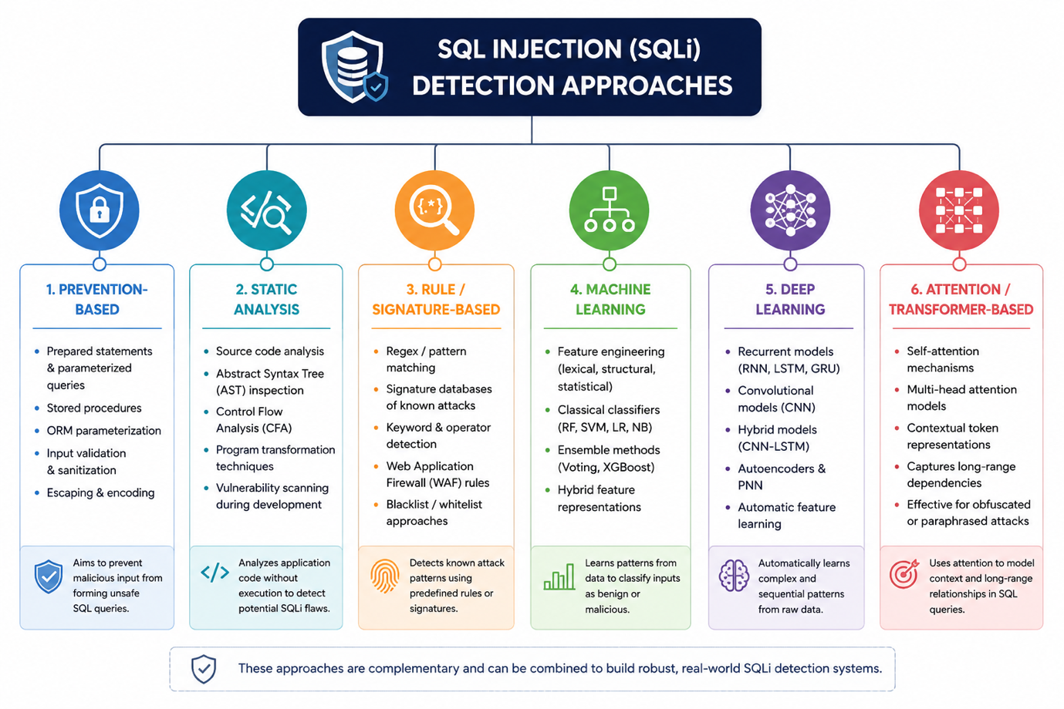
Figure 2.1 presents a taxonomy of SQL injection detection approaches identified in the literature, illustrating the progression from preventive and static techniques to machine learning, deep learning, and transformer-based methods.
2.4 Machine Learning for SQL Injection Detection
The application of machine learning in SQL injection detection is driven by the capacity of models to recognise persistent structural and lexical patterns. Instead of manually encoding each possible injection string, classifiers can identify patterns in token utilisation, query architecture, punctuation, and operator combinations.
Rosca, Stancu and Popescu (2025) provide one of the most significant current examples for the present dissertation. Their research presents a two-stage pipeline featuring syntactic normalisation and subsequent semantic feature extraction. Utilising a dataset of 90,000 queries that combines public and synthetic data, they demonstrate robust performance from a Voting Ensemble model and argue that the model can function as a supplementary security layer within an established web application framework. This is particularly pertinent to the current study as it confirms the architectural choice to incorporate ML between input retrieval and query execution, rather than positioning it as a substitute for prepared statements or other conventional safeguards.
Other research similarly indicate solid conclusions for classical classifiers. Le et al. (2023), Peralta-Garcia et al. (2023), and Banimustafa et al. (2024), as summarised by Rosca, Stancu and Popescu (2025), all demonstrate that tree-based ensembles such as Random Forest remain extremely competitive. Farooq (2021) similarly reports robust results using ensemble learning, whereas Shareef, Hasan, and Farhan (2023) investigate logistic-regression-based SQL payload analysis within a huge data environment.
This literature suggests that SQL injection detection significantly improves with well-structured feature spaces. Hybrid representations that integrate lexical data, keyword indications, structural symbols, and token-frequency metrics are consistently linked to superior performance.
2.5 Deep Learning and Sequence-Based Models
A second significant focus in the literature pertains to the application of deep learning for automatic or semi-automatic feature extraction. Muslihi and Alghazzawi (2020) examine the use of deep learning in SQL injection detection and determine that recurrent and convolutional models are particularly promising, especially for tasks requiring the learning of sequential relationships..
Thalji et al. (2023) integrate characteristics produced from autoencoders with XGBoost, yielding robust outcomes, whereas Alghawazi, Alghazzawi, and Alarifi (2023) employ an RNN autoencoder for SQL injection detection. Alarfaj and Khan (2023) exhibit robust performance utilising a Probabilistic Neural Network. Tadhani et al. (2024) demonstrate elevated accuracy for a CNN-LSTM methodology in safeguarding web applications from XSS and SQLi vulnerabilities. These results indicate that deep learning may be particularly advantageous when the query structure is intricate or when feature engineering is inadequate.
Nevertheless, the literature indicates that deep learning does not ensure dominance in all contexts. In highly organised applications where explicit feature engineering already captures most biased information, classical ensemble approaches may nonetheless match or surpass complex neural models. The argument is relevant to the present dissertation, which contrasts traditional machine learning, deep neural networks, long short-term memory networks, and gated recurrent units within a unified framework.
2.6 Explainability and Interpretability in SQLi Detection
A significant deficiency in several SQLi detection investigations is the insufficient focus on interpretability. In cybersecurity contexts, security analysts and engineers frequently require understanding of the rationale behind an input being flagged, rather than merely its flagged status. Mahmood (2025) tackles this issue by incorporating explainability into SQL injection detection and employing LIME to enhance the transparency of model predictions. The research argues that interpretability facilitates the closure of the trust gap typically linked to opaque security classifiers.
This aspect is significant for the current dissertation, despite LIME not being directly incorporated into the implemented middleware. It confirms the argument that future SQLi detection solutions ought not to be evaluated exclusively on quantitative performance parameters. Transparency, analyst trust, and practical interpretability also matter, particularly where blocking decisions affect legitimate application users.
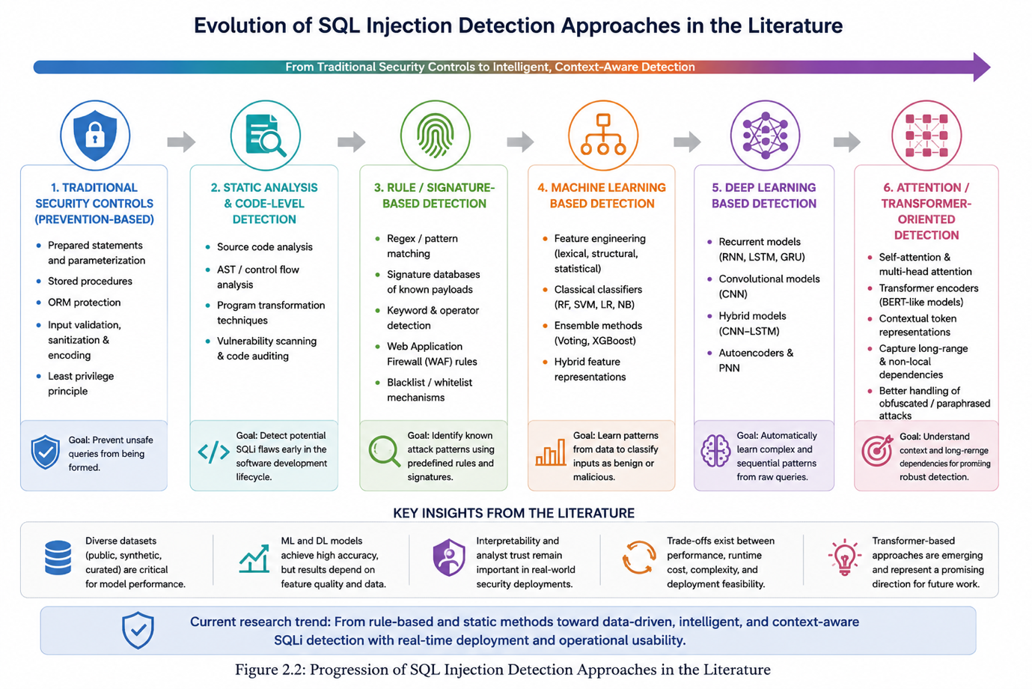
Figure 2.2: Literature synthesis showing the progression of SQL injection detection from traditional security controls to machine learning and transformer-based approaches.
2.7 Attention-Based and Transformer-Oriented Approaches
Since this dissertation specifically addresses "Transformer Models," the literature review should include a distinct portion on transformer-related research. While the transformer literature on SQL injection detection is less comprehensive than that on ensemble learning or recurrent models, there is indication that attention-based methods are developing as significant alternatives.
Lo, Hwang, and Tai (2025) propose a simplified multi-head self-attention methodology for the detection of SQL injection. This is especially important because self-attention mechanisms can capture long-range dependencies and token interactions more flexibly than strictly sequential recurrent models. This may render them more effective at handling altered attack strings if suspicious tokens are distributed across the query.
From a conceptual perspective, transformer and self-attention techniques may provide three potential improvements over the models utilised in the current study:
- enhanced contextual modelling of tokens and symbols
- improved management of long-range or non-local dependencies
- increased adaptability for learning obfuscated or paraphrased attack versions
At the same time, they may incur increased computational costs, more stringent training requirements, and increased challenges in real-time implementation relative to traditional ensemble models. This trade-off clarifies why the current dissertation can appropriately concentrate on solid machine learning baselines and deployment viability, while framing transformer methodologies as a key direction for future research.

2.8 Datasets Used in SQLi Research
The quality and origin of training data are important to SQLi detection efficacy. Numerous research depend on curated benchmark datasets, Kaggle resources, synthetic payload production, or combinations of them. Rosca, Stancu, and Popescu (2025) expressly integrate synthetic data with public data, partially justifying this on the basis of privacy considerations. Mahmood (2025) additionally utilises public datasets, highlighting the importance of preprocessing, tweaking, and interpretability.
This dissertation primarily utilises the Rule-Based SQL Injection (RbSQLi) dataset (Mullick et al., 2025), which offers an extensive collection of labelled SQL query records with several attack families. This is a methodological advantage as it facilitates both binary categorisation and descriptive analysis of attack types. However, it is important to acknowledge a potential limitations common in the literature: curated rule-based datasets may exhibit greater regularity and separability compared to real-time traffic. This may somewhat explains why certain published research indicate exceedingly high accuracy.
2.9 Common Evaluation Metrics in SQLi Detection Research
The primary assessment metrics identified in the literature include accuracy, precision, recall, F1-score, AUC, and confusion matrices. More recent research highlight the importance of weighted averages, Matthews correlation coefficient, and false positive counts, particularly in the context of data imbalance (Rosca, Stancu, and Popescu, 2025). Mahmood (2025) similarly compares various classifiers across two datasets and addresses model explainability in conjunction with traditional classification metrics.
In a security-sensitive operation like SQL injection detection, recall is of paramount importance as false negatives represent undetected attacks. Precision is paramount, as excessive numbers of false positives may result in the obstruction of real traffic. The F1-score is therefore utilised as a balancing statistic, particularly when benign and malicious instances are unevenly distributed.
2.10 Research Gaps in the Existing Literature
Despite the maturity of the field, several gaps remain evident:
First, a significant portion of the literature highlights benchmark-level performance while devoting insufficient focus on real deployment. Models may exhibit 97–99% accuracy during offline tests; however, this doesn't guarantee satisfactory performance when integrated into an actual request-processing pipeline.
Secondly, many studies focus on attaining the optimal metric instead of examining the trade-offs among interpretability, runtime cost, maintainability, and deployment simplicity. This is particularly relevant for security middleware, where decisions must be explained and operationally viable..
Third, transformer-based methodologies are relatively under-represented when compared with classical ensembles and recurrent neural networks. Although the emergence of attention-based methods, such as those suggested by Lo, Hwang, and Tai (2025), the research lacks a clear consensus on the conditions in which transformer-like structures significantly surpass robust machine learning baselines in SQL injection detection.
Fourth, studies often evaluate models on one or two datasets only, leaving open questions about generalisability across attack families, query styles, and application contexts.
Finally, there remains a persistent gap between high reported performance and demonstrable runtime integration. The present dissertation addresses this gap by coupling model training with middleware deployment and log-based runtime evaluation.
2.11 Chapter Summary
Research shows that SQL injection continues to be a significant web security threat, while machine learning has emerged as an increasingly effective supplementary detection method. Classical ensemble methods, particularly Random Forest and similar techniques, regularly exhibit robust performance when integrated with well crafted features. Deep learning models, including recurrent and hybrid architectures, exhibit potential, especially in sequence-sensitive settings. Recent studies highlight interpretability and self-attention as significant approaches, however research on transformer-oriented SQL injection remains somewhat limited..
The review identifies multiple outstanding concerns, such as dataset realism, model interpretability, deployment feasibility, and insufficient comparisons between high-performing baselines and newer attention-based techniques. These gaps justify the present study, which develops an SQLi detection application that not only evaluates multiple models but also deploys the selected best model within a Flask middleware architecture.

